**Unit 10: In the park**

1. **New words** (từ mới): Học sinh bấm vào file 89 để nghe cách đọc từ mới, đọc theo nhiều lần cho đến khi đọc được thuộc trôi chảy. (sách student book trang 74)

Thực hành: viết vào vở mỗi từ 3 hàng.

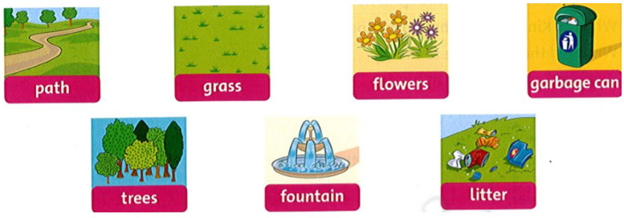

**Script:**

Path: con đường Grass: cỏ

Flowers: bông/ hoa Garbage can: thùng rác

Trees: cây (cây thân cứng) Fountain: đài phun nước

Litter (Verb): xả rác Litter (Noun): rác

1. **Reading (đọc hiểu) (student book, 74)**

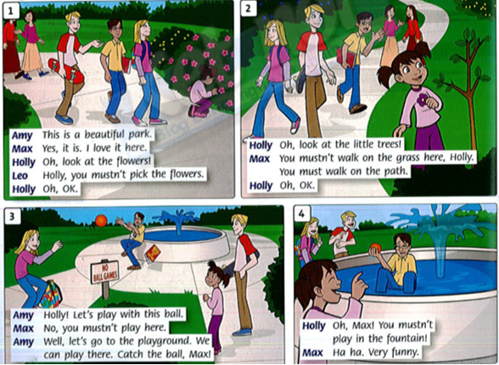

* **Đầu tiên HS chỉ nhìn hình và trả lời các câu hỏi sau:**

1. Where are they all now?

* ………………………………………………………

1. How many people are there in picture 1?

* ………………………………………………………

1. Where is Holly in picture 2, on the path or on the grass?

* ………………………………………………………

1. Is Max playing with a ball in picture 3?

* ………………………………………………………

1. Where is Max now in picture 4 ?

* ………………………………………………………
* **Sau khi khi nhìn hình trả lời các câu hỏi trên, HS nghe file 90 nhiều lần cho đến khi hiểu nghĩa và đọc theo cho trôi chảy.**
* **Hs tự thực hành đóng vai trong bài đôi thoại vài lần.**

**Script:**

1. Amy: This is a beautiful park.

Max: Yes, it is. I love it here.

Holly: Oh, look at the flowers!

Leo: Holly, you mustn't pick the flowers.

Holly: Oh, OK.

2. Holly: Oh, look at the little trees!

Max: You mustn't walk on the grass here, Holly. You must walk on the path.

Holly: Oh, OK.

3. Amy: Holly! Let's play with this ball.

Max: No, you mustn't play here.

Amy: Well, let's go to the playground. We can play there. Catch the ball, Max!

4. Holly: Oh, Max! You mustn't play in the fountain!

Max: Ha ha, very funny

* **Sau đó viết các câu hỏi sau vào vở và trả lời:**

1. Who are they in the picture?

* ………………………………………………

1. Does Max love the park?

* ………………………………………………

1. Do they all walk on the path now in picture 2?

* ………………………………………………

1. What does Amy want to do in picture 3?

* ………………………………………………

1. Do they all feel funny in picture 4 ?

* ………………………………………………

1. **Grammar:** ngữ pháp (student book/75)

**HS nghe file 91 và đọc theo vài lần.**

|  |  |
| --- | --- |
| We must do our homework.  They mustn’t talk in class. | Mustn’t = must not |
| You must walk on the path.  You mustn’t walk on the grass. | Sometimes “you” means everyone. |

* “**Must**” có nghĩa là “**phải**” làm gì đó. (mang nghĩa hơi bắt buộc)

Vd: You must be quite in the library. -> Bạn phải giữ im lặng trong thư viện.

* “**Mustn’t**” có nghĩa là “**không phải/ không được** ” làm gì đó. (cũng mang nghĩa hơi bắt buộc)

Vd: you mustn’t ride bike here. -> Bạn không được chạy xe đạp ở đây.

**Practice: 1. Read and match.**

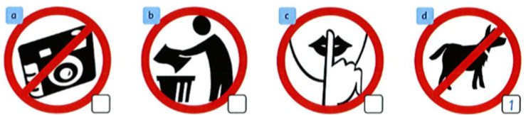

1. You mustn’t walk your dog here.
2. You must put litter in the garbage can.
3. You mustn’t take photos here.
4. You must be quite.

**2. Write : must / mustn’t**

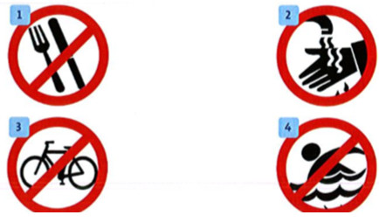

1 You mustn’t eat here.

2. You ________ wash your hands.

3. You _________ ride your bike here.

4. You ________ swim here.

**3. Look, say and write: (nhìn, nói, sau đó viết câu ra vở)**

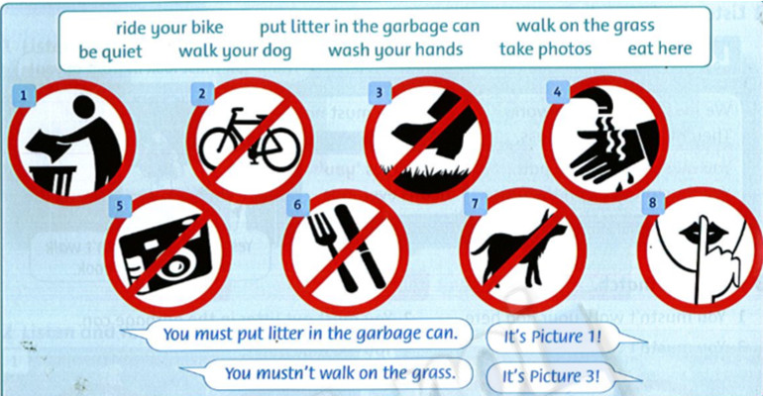

1. Picture 1: You must put litter in the garbage can.
2. Picture 2……………………………………………………………………………
3. Picture 3………………………………………………………………………………
4. Picture 4...……………………………………………………………………………
5. Picture 5……………………………………………………………………...............
6. Picture 6………………………………………………………………………………
7. Picture 7…………….…………………………………………………………………
8. Picture 8………….……………………………………………………………………

**4. Write six sentences about what you must / mustn’t do in your class or in your house**.

Ex: You must listen to your teacher in your class.

You must be friendly in your class.

1…………………………………………………………………………………………

2…………………………………………………………………………………………

3…………………………………………………………………………………………

4…………………………………………………………………………………………

5………………………………………………………………………………...............

6…………………………………………………………………………………………

1. **Song. (HS nghe file 92 và hát theo cho đến khi thuộc )**

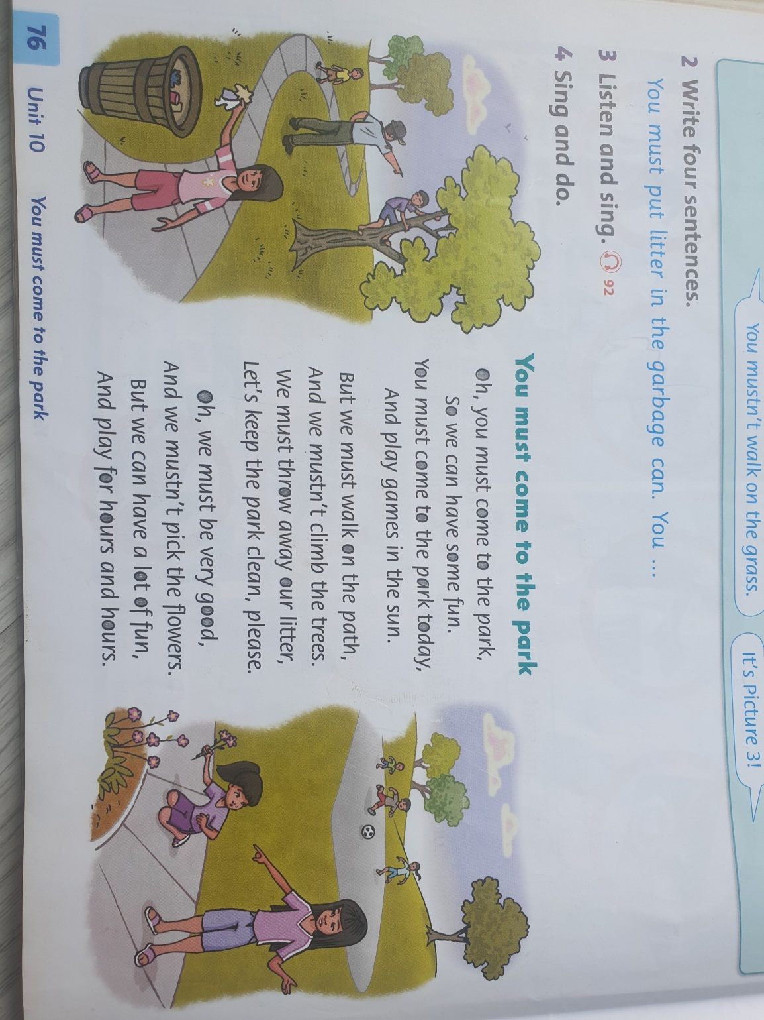

**Script:**

**You must come to the park**

**Oh, you must come to the park,**

**So we can have some fun.**

**You must come to the park today.**

**And play games in the sun.**

**But we must walk on the path,**

**And we mustn't climb the trees.**

**We mustn't throw away our litter,**

**Let's keep the park clean, please.**

**Oh, we must be very good,**

**And we mustn'tpick the flowers.**

**But we can have a lot of fun,**

**And play for hours and hours.**

**Answer key**

* **Đáp án phần nhìn hình và trả lời các câu hỏi:**

1. Where are they all now?

* They are all at the park now.

1. How many people are there in picture 1?

* There are 6 people in the picture.

1. Where is Holly in picture 2, on the path or on the grass?

* She is on the grass.

1. Is Max playing with a ball in picture 3?

* No, he isn’t.

1. Where is Max now in picture 4 ?

* He’s in the fountain.
* **Đáp án phần viết các câu hỏi vào vở và trả lời:**

1. Who are they in the picture ?

* They are Max, Holly, Amy and their moms.

1. Does Max love the park?

* Yes, he does.

1. Do they all walk on the path now in picture 2?

* No, they don’t.

1. What does Amy want to do in picture 3?

* She wants to play with a ball with Max.

1. Do they all feel funny in picture 4 ?

* No, they don’t.

**Practice:**

**1. Read and match**

1 – d 2 – b 3 – a 4 – c

**2. write: must / mustn’t**

2. must 3. mustn't 4. mustn't

**3. Look, say and write**

Picture 2: You mustn't ride your bike here.

Picture 3: You mustn’t walk on the grass.

Picture 4: You must wash your hands.

Picture 5: You mustn't take photos.

Picture 6: You mustn't eat here.

Picture 7: You mustn't walk your dog here.

Picture 8: You must be quiet.

**4. Write six sentences**: (đây là các câu gợi ý các em có thể làm khác và gửi cho GV để sửa)

1. You mustn’t talk to your friends in your class.

2. you mustn’t eat in your class.

3. You must put litter in the garbage can in your house.

4. you mustn’t fight your friends in your class.

5. you mustn’t watch TV too much in your house.

6. you must wash your hands before you eat meals.